Azure Project Method-3:

Deploying Static Website using Azure Load Balancer by ARM Template.

-> Make your Website Template available on Github

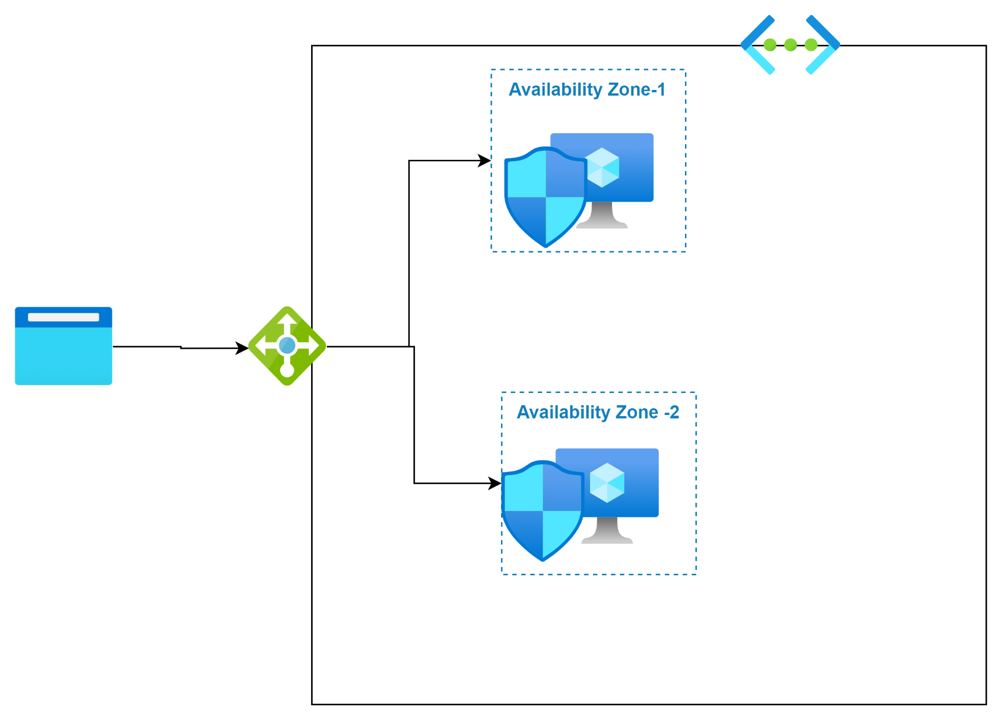

1. Create a resource group
2. Create a virtual network with two subnets
3. Create a network security group and open 80 port from anywhere
4. Create a virtual machine VM-1 with userdata as the following script

#!/bin/bash
sudo apt update
sudo apt install nginx git -y
cd /tmp && git clone https://github.com/hariharandevarakonda/HMGYM.git mysitee
sudo rm -rf /var/www/html/index.nginx-debian.html
sudo cp -r /tmp/mysitee/* /var/www/html

5. Create one more virtual machine
6. Create a Standard load balancer and perform routing to Virtual Machine.

